**Software Engineering**

1. What do you understand by SDLC? What are the phases of SDLC model?

**Answer**

The system development life cycle is a conceptual model used in project management that describes the stages involved in on information system development project from an initial feasibility study through maintenance of the completed application.

Phases:

Recognition

Feasibility Study

Analysis

Design

Implementation

Maintenance

Consideration

2. Define alpha-beta testing.

**Answer:**

Alpha testing is simulated or actual operational testing by potential users/customers or an independent test team at the developers' site.

In software development, a beta test is the second phase of software testing in which a sampling of the intended audience tries the product out. Beta testing is also sometimes referred to as user acceptance testing (UAT) or end user testing.

3. What is waterfall model? Define the phases of waterfall model.

It is also referred to as a linear-sequential life cycle model. It is very simple to understand and use. In a waterfall model, each phase must be completed before the next phase can begin and there is no overlapping in the phases. The Waterfall model is the earliest SDLC approach that was used for software development.

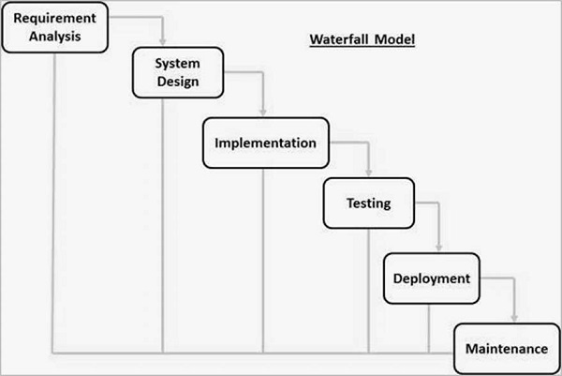

4. What is extreme programming? Is pair programming an extreme programming concept?.

**Answer:**

Extreme programming (XP) is a [software development methodology](https://en.wikipedia.org/wiki/Software_development_methodology) which is intended to improve software quality and responsiveness to changing customer requirements. As a type of [agile software development](https://en.wikipedia.org/wiki/Agile_software_development),it advocates frequent "releases" in short development cycles, which is intended to improve productivity and introduce checkpoints at which new customer requirements can be adopted.

Pair programming is an Agile technique originating from Extreme programming (XP) in which two developers team together and work on one computer. The two people work together to design, code and test user stories. One, the driver, writes code while the other, the observer or navigator, reviews each line of code as it is typed in.

**System analysis, design and development**

1. What Are Structured Analysis Tools?

**Answer**

Data Flow Diagrams.

Data Dictionary.

Decision Trees.

Decision Tables.

Structured English.

Pseudocode.

2. What is feasibility study? Write down the steps that are involved in feasibility study?

**Answer**

Feasibility Study can be considered as preliminary investigation that helps the management to take decision about whether study of system should be feasible for development or not.

Steps:

* Form a project team and appoint a project leader. Develop system flowcharts.
* Identify the deficiencies of current system and set goals.
* Enumerate the alternative solution or potential candidate system to meet goals.
* Determine the feasibility of each alternative such as technical feasibility, operational feasibility, etc.
* Weight the performance and cost effectiveness of each candidate system.
* Rank the other alternatives and select the best candidate system.
* Prepare a system proposal of final project directive to management for approval.

3. What are the elements of a system?

**Answer**

Input and output

Processors

Control

Feedback

Environment

Boundaries and interface

4. What is system analyst? What are the roles of system analyst?

**Answer**

A person who conducts a methodical study and evaluation of an activity such as a business to identify it’s desired objective in order to determine procedure by which these objectives can be gained.

Roles:

Change agent

Investigator

Architect

Psychologist

Salesperson

Motivator

Politician